NFTs IN THE FASHION SYSTEM

One of the deepest interactions between artificial intelligence and intellectual property are certificates of authenticity related to digital work, both native digital and simply digital reproduction. These certificates, so called NFT, are wildly use in crypto art but they are getting a tool of interest also in the luxury system.

Cryptoart is digital art certified and traded via blockchain. A crypto artwork is a digital content, uploaded to an exchange platform which could be a marketplace where every purchase is recorded on the blockchain. To be sold, digital works are associated with an NFT. NFTs are non-divisible virtual objects that can have a unique relationship with the work they represent and guarantee their uniqueness, allowing them to be transferred and sold online.

The NFTs support the fashion system in the digital transformation, providing new solutions in the field of protection of copyright , for the registration of sketches and models and in general as a strategic asset also in terms of sustainability, although NFTs cannot be considered zero impact right now.

NFTs, non-fungible tokens, are cryptographic assets created with blockchain technology and unique, distinguishable and non-interchangeable identification codes. The feature that differentiates them from the most famous cryptocurrencies lies in the fact that while virtual money can be replaced with another identical cryptocurrency, NFTs are equivalent
to collectible digital certificates that allow you to ascertain the authenticity and the ownership of something unique. NFTs are not fungible and therefore cannot be an instrument of exchange, on the contrary they are certificates that guarantee the uniqueness of the asset to which they are linked.

The main characteristics of NFT are uniqueness and exclusivity. We immediately understand why, especially for the luxury system they could be really appealing both for the expectations of customers and brands operating in this market.

A first application of NFTs in the fashion supply chain is linked to phygital. Therefore, when a consumer is purchasing a physical product such as an apparel, he/she would simultaneously receive an NFT representing the same product but in digital format on the blockchain that can be used in augmented reality or virtual gaming arenas.

A further application of NFTs concerns the merger between the video game and fashion industry. This combination offers unlimited opportunities for creativity, which will go beyond the physical limits of the fashion industry, being avatars of any shape, you wish.

The most important collaborations in this field are The North Face, Gucci, Balenciaga, Prada and many other brands in the world of luxury with the actors of the gaming world, such as Pokemon Go, Honor of Kings, Fortnite and GTA and of course the Ralph Lauren’s collaboration with Snapchat. The collaboration between Balenciaga and Fortnite, made it possible to purchase clothes inspired by various Balenciaga designs for the gaming world.

Dolce and Gabbana also released a digital collection consisting of nine NFT clothing items, calling it the “Genesis Collection”. Sold for approximately $ 5.7 million, the collection has become the most expensive digital collection ever.

Fashion, digital, gaming and NFT are the key words of fashion houses to approach Gen - Z, improve the customer journey and reduce the impacts deriving from the Covid -19 pandemic and of course to drive the digital transformation in the fashion system.

There are many collaborations between fashion brands and digital artists also to offer unique services and experiences for exclusive events and occasions, also involving influencers and their community. Among the main collaborations:

- RTFKT company and digital artist Fewocious for the creation of sneakers and related NFTs, sold out with a profit of 3.1 million dollars;
- the accreditations for Paris Fashion Week accompanied by the NFTs of Richard Haines, the renowned fashion illustrator;
- in 2019, The Fabricant and Cartlings teamed up to create the first digital-only blockchain suit, which sold for $ 9,500.

Needed to also mention Gucci’s digital sneakers. Gucci has launched a pair of sneakers on the market at a price of 12.99 euros. It was just virtual sneakers and, technically, a Non-Fungible Token. Designed by the creative director of Gucci, Alessandro Michele, the NFT-sneakers can be purchased through Wanna Kicks, an innovative App that uses augmented reality ("AR"), through which, thanks to a 3D filter, the user can, not only, wear -virtually- virtual shoes, but also, photograph oneself with the new purchase.

The uses of NFTs are truly manifold.In our legal system, creative works related to fashion can find, in general, two main forms of protection and in particular:

- the protection deriving from copyright;
- the protection deriving from art. 31 of the Intellectual Property Code, according to which the registration of a design or model gives the owner the exclusive right to use it and to prohibit third parties from using it without his consent.

If it is true that copyright arises with the creation of the work, it is equally true that the copyright is often the core of litigations.

The use of blockchain technology - which has been regulated in our system through art.8 ter of the Decreto Semplificazioni 2019, could be an adequate tool for certifying the authorship of the work and its dating. The author (and therefore the stylist or the draftsman or even the fashion house) could deposit his sketch by NFT in the blockchain, in order to pre-establish an evidence about the date of creation and its content.

In other words, the deposit of that NFT in the blockchain would at least allow to establish a presumption regarding the authorship of that work (of that sketch, of that item of clothing) in order to have greater protection in a hypothetical judgment where the author must prove the authorship or creation date of the work.
Sustainable applications of NFTs

The Givenchy case is a remarkable use of NFT in an ethical and sustainable way. Givenchy has created a set of 15 NFT, all minted on Polygon, an eco-friendly Ethereum-compatible network in collaboration with the graphic artist Chito, auctioned on Open Sea. Proceeds raised from the NFT auction will go to Givenchy's charity partner, The Ocean Cleanup, a nonprofit developing technology to eliminate plastic pollution. Givenchy's journey into the world of NFTs and social engagement continues as it had previously demonstrated through support to the LGBTQIA + community during pride month by launching an unprecedented project: the brand has decided to team up with London gallery owner Amar Singh and the Rewind artist collective to create a digital artwork which will be sold for the benefit of the “Le MAG Jeunes association”.

Titled “Pride”, the artwork created by Rewind Collective for Givenchy Parfums is a series of animated portraits reinterpreted digitally in the colors of the Rainbow, symbolizing diversity, the assertion of identity and the fight for equal rights. Thus expressing Givenchy’s commitment to a more diverse, more inclusive and universal kind of beauty.

The use of blockchain technology, however, has implications in terms of environmental impact. Especially the minting process involves considerable polluting emissions. Up to now it has been considered that the consumption generated by blockchain technology is necessary to guarantee the correct functioning of the validation and consensus mechanism of the nodes developed on a technology based on Proof of Work. Only the process of creating Bitcoins, according to research from the University of Cambridge, uses more
electricity than countries like Argentina, Sweden or Pakistan.

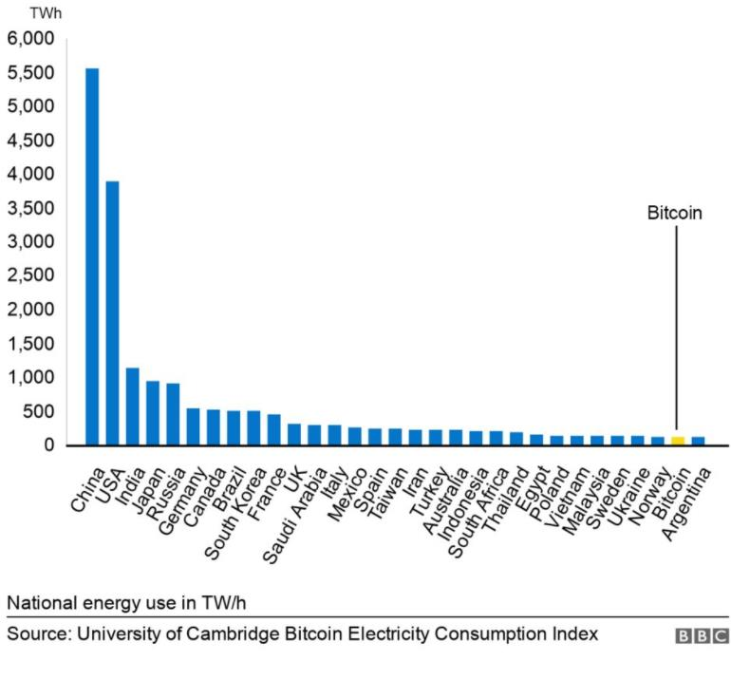

The NFTs, which derive from the same applicative and mechanical principle, are no different and for a long time they have been the subject of criticism as not eco -sustainable.

It is estimated that creating a single NFT produces on average as much pollution as a 800 - kilometer journey in a gasoline-powered car.

NFTs are likely to further aggravate this situation unless alternatives to the current creation process are found. At present, NFTs use Ethereum (the second cryptocurrency as a value after Bitcoin) to create the unique tokens that characterize them, exploiting an extremely polluting process given the computing power required by the computers on the network.

Therefore, their real success and future application also depends on innovations in terms of technological sustainability.

And therefore a new eco-sustainable NFT platform was presented. This is MUSA, an Italian zero-impact NFT marketplace, created with the technological support of Blockchain Italia. The blockchain on which MUSA creates (or rather "undermines") the NFTs is Algorand, which instead is to be considered a highly ecological technology,

because its consensus mechanism allows the nodes participating in the decentralized network to validate transactions with practically no energy consumption.

Jae Slooten, co-founder of the pioneering Dutch digital fashion brand "The Fabricant", argues that real-world fashion will become increasingly technological and sustainable, with intelligent materials that act like a second skin and are able to monitor our body.

"I feel the future lies in materials that are intelligent and that are able to grow with us or even grow on us," Slooten explained, adding that the physical world will allow people to exhibit "a more sober expression of who they are". Otherwise, according to Slooten, the expressive part will be translated into virtual reality. "And then, within the digital world, we can go completely crazy. We can wear a dress made of water or have lights everywhere and change your textile according to your mood”.

Available at: www.givenchybeauty.com
University of Cambridge Bitcoin Electricity Consumption Index 2020
Available at: www.consulpress.eu

